Product Type: | comfortable competitive colorful logo cabrettal golf glove for sale
Material: | Cabretta Leather
Model number: | TH-GL1017
LOGO: | Embroidered/Rubber/Silicone/printing/empoxy meet your request
MOQ: | 500 pcs
Place of Origin | Fujian, China (Mainland)
Color: | colorful,can be custom
Brand name: | OEM
size: | s/m/l/xl/xxl
comfortable competitive colorful logo cabrettal golf glove for sale

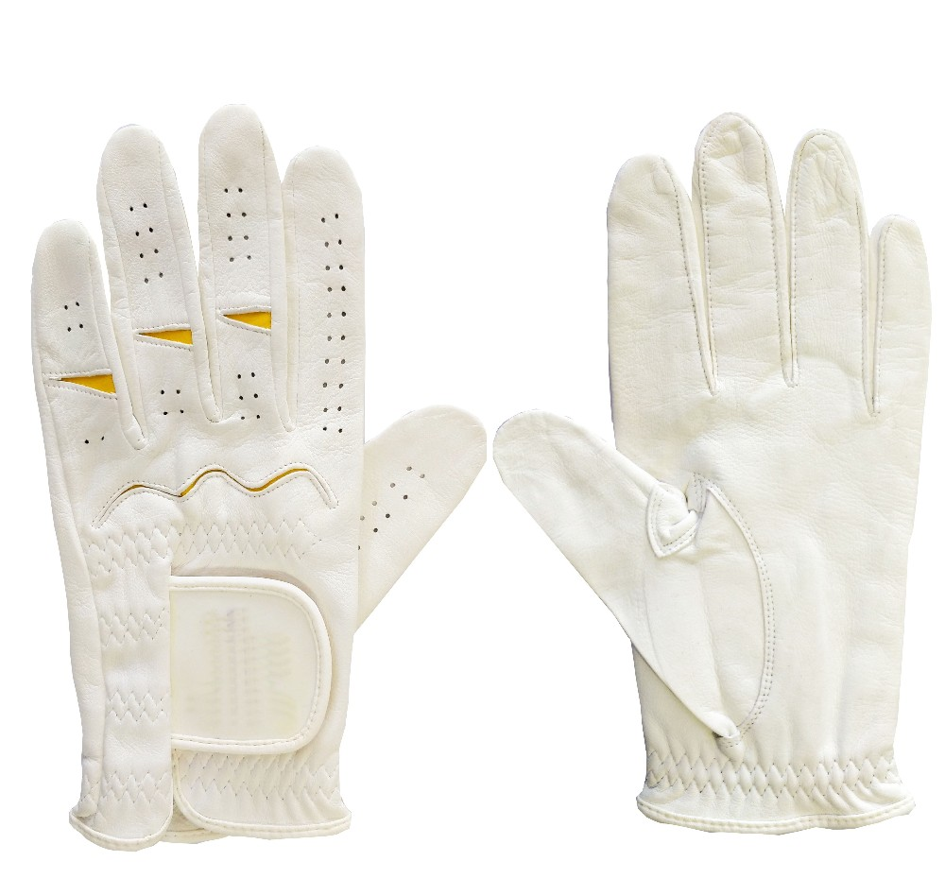
More information please click:www.tt-golf.com

