Fashionable New Golf stand bag

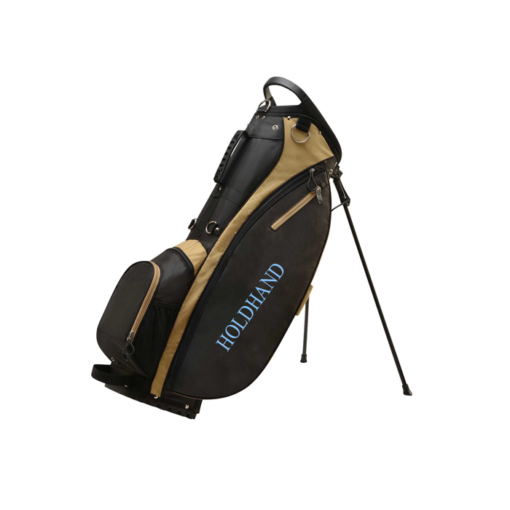

1.Lightweight design;High quality polyester/nylon construction ensures long lasting durability.
2.(5) club dividers keep clubs separated and secured;
3.Velour lined water-resistant valuables pocket; metal towel loop; Velcro glove holder; insulated cooler pocket.

