Custom logo golf stand bag

- Full length Apparel pocket
- Easy grab handle
- Seamless Tee pocket
- 5-way top with full length dividers

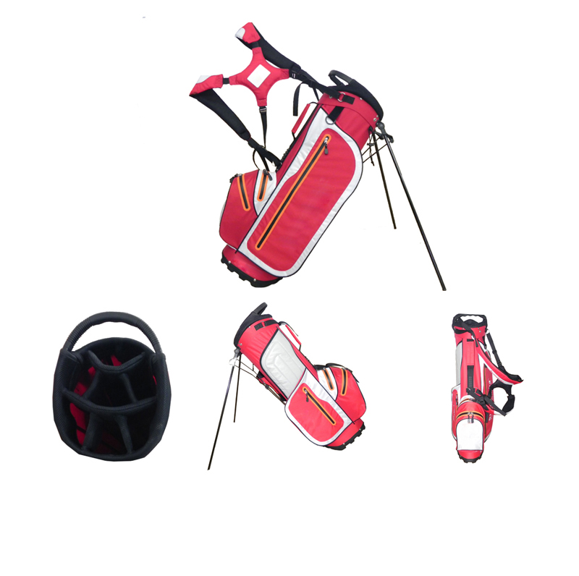
More information please click : www.tt-golf.com

